**Assessment – 3**

**CRUD Todo App with Mongoose**

By

Ayush Solanki

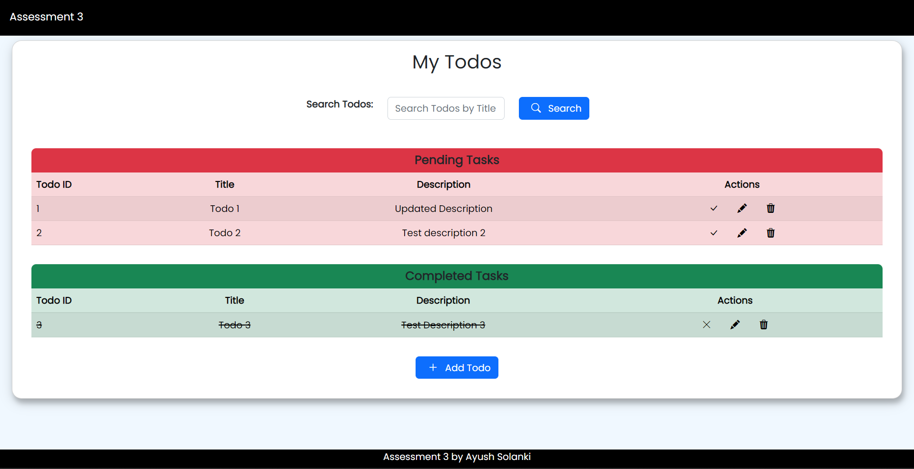

1. Run backend by following commands

* cd backend
* npm i
* npm start

1. Run the frontend in separate terminal by running “npm start”